Packet Tracer – Configuring OSPFv2 in a Single Area

1. Topology

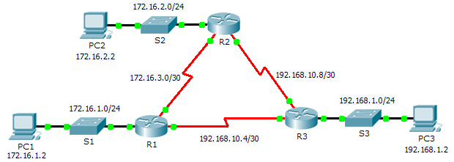

1. Addressing Table

|  |  |  |  |  |
| --- | --- | --- | --- | --- |
| Device | Interface | IP Address | Subnet Mask | Default Gateway |
| R1 | G0/0 | 172.16.1.1 | 255.255.255.0 | N/A |
| S0/0/0 | 172.16.3.1 | 255.255.255.252 | N/A |
| S0/0/1 | 192.168.10.5 | 255.255.255.252 | N/A |
| R2 | G0/0 | 172.16.2.1 | 255.255.255.0 | N/A |
| S0/0/0 | 172.16.3.2 | 255.255.255.252 | N/A |
| S0/0/1 | 192.168.10.9 | 255.255.255.252 | N/A |
| R3 | G0/0 | 192.168.1.1 | 255.255.255.0 | N/A |
| S0/0/0 | 192.168.10.6 | 255.255.255.252 | N/A |
| S0/0/1 | 192.168.10.10 | 255.255.255.252 | N/A |
| PC1 | NIC | 172.16.1.2 | 255.255.255.0 | 172.16.1.1 |
| PC2 | NIC | 172.16.2.2 | 255.255.255.0 | 172.16.2.1 |
| PC3 | NIC | 192.168.1.2 | 255.255.255.0 | 192.168.1.1 |

1. Objectives

Part 1: Configure OSPFv2 Routing

Part 2: Verify the Configurations

1. Background

In this activity, the IP addressing is already configured. You are responsible for configuring the three router topology with basic single area OSPFv2 and then verifying connectivity between end devices.

1. Configure OSPFv2 Routing
   1. Configure OSPF on the R1, R2 and R3.

Use the following requirements to configure OSPF routing on all three routers:

* 1. Process ID 10
  2. Router ID for each router: R1 = 1.1.1.1; R2 = 2.2.2.2; R3 = 3.3.3.3
  3. Network address for each interface
  4. LAN interface set to passive (do not use the **default** keyword)
  5. Verify OSPF routing is operational.

On each router, the routing table should now have a route to every network in the topology.

1. Verify the Configurations

Each PC should be able to ping the other two PCs. If not, check your configurations.